Name: Ningyuan Zhang

Course: Cpr E 381

Section: K

Date: 9/28/2016

Group: K-3

TA: Taewoon Kim

Lab 4 Report

Part 1.

a).

all arithmetic immediate values are sign-extended. all operands need be zero extended.

b).

we will need 8bit to 32bit sign-extender and zero exxtender.

d).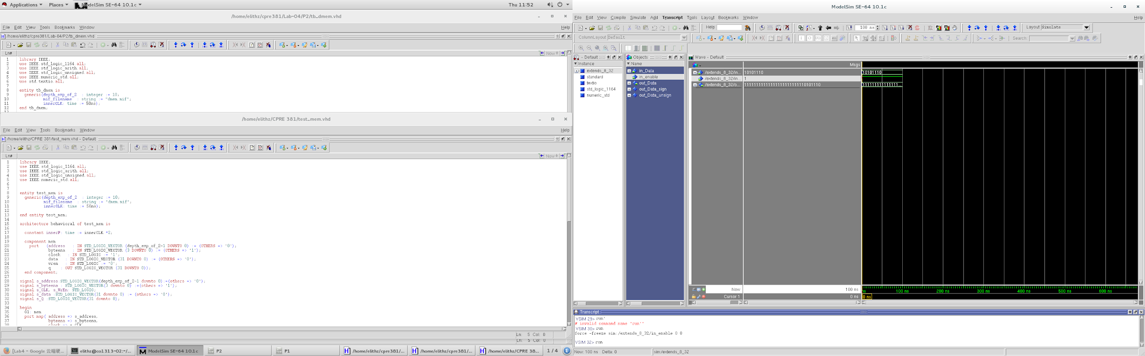

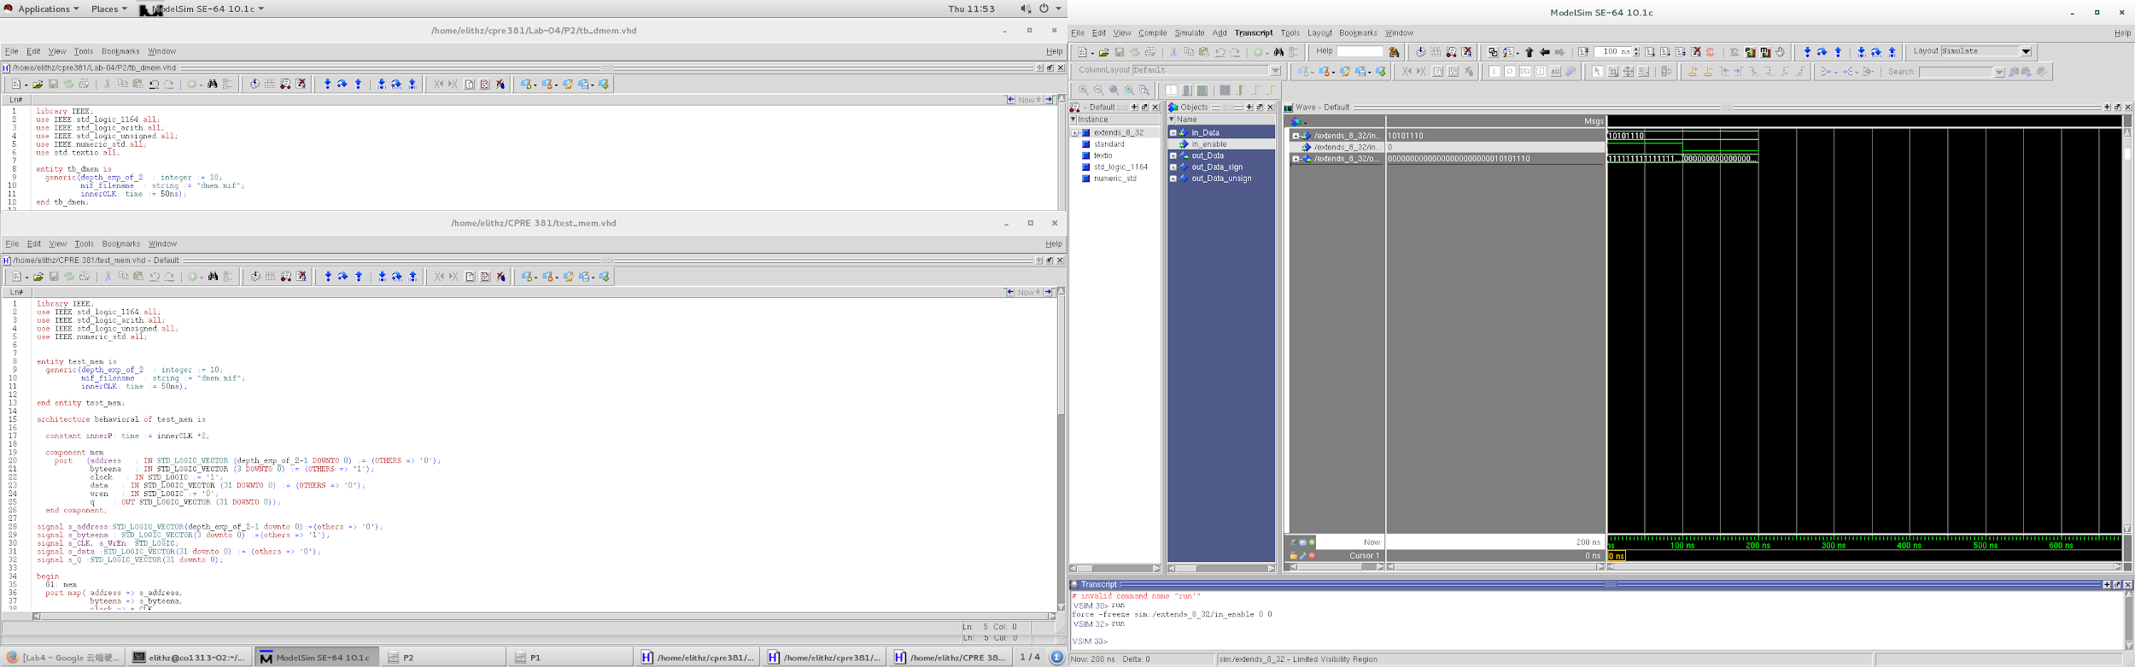

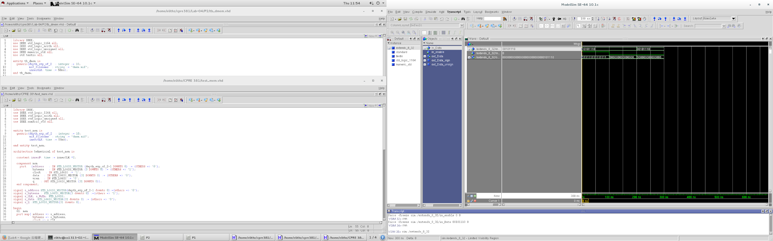

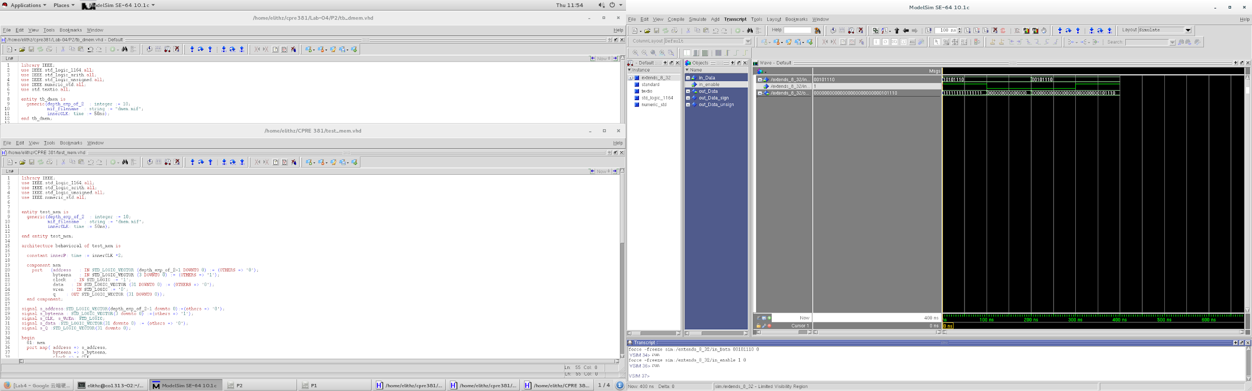

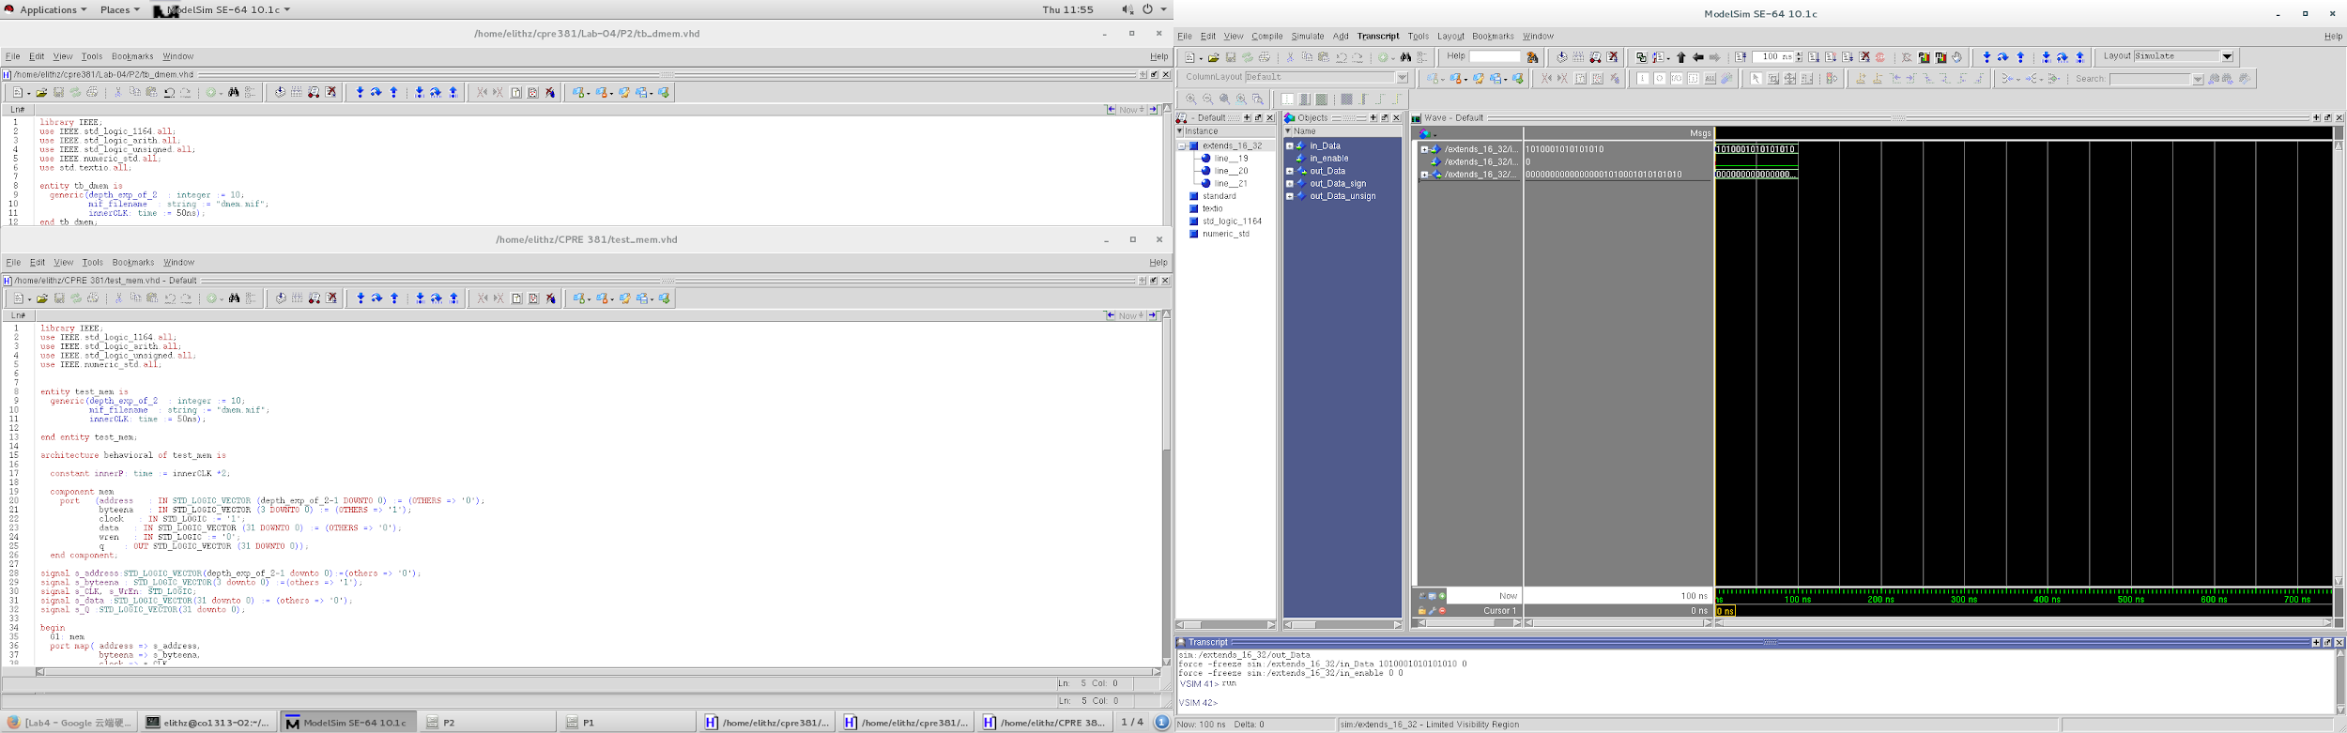

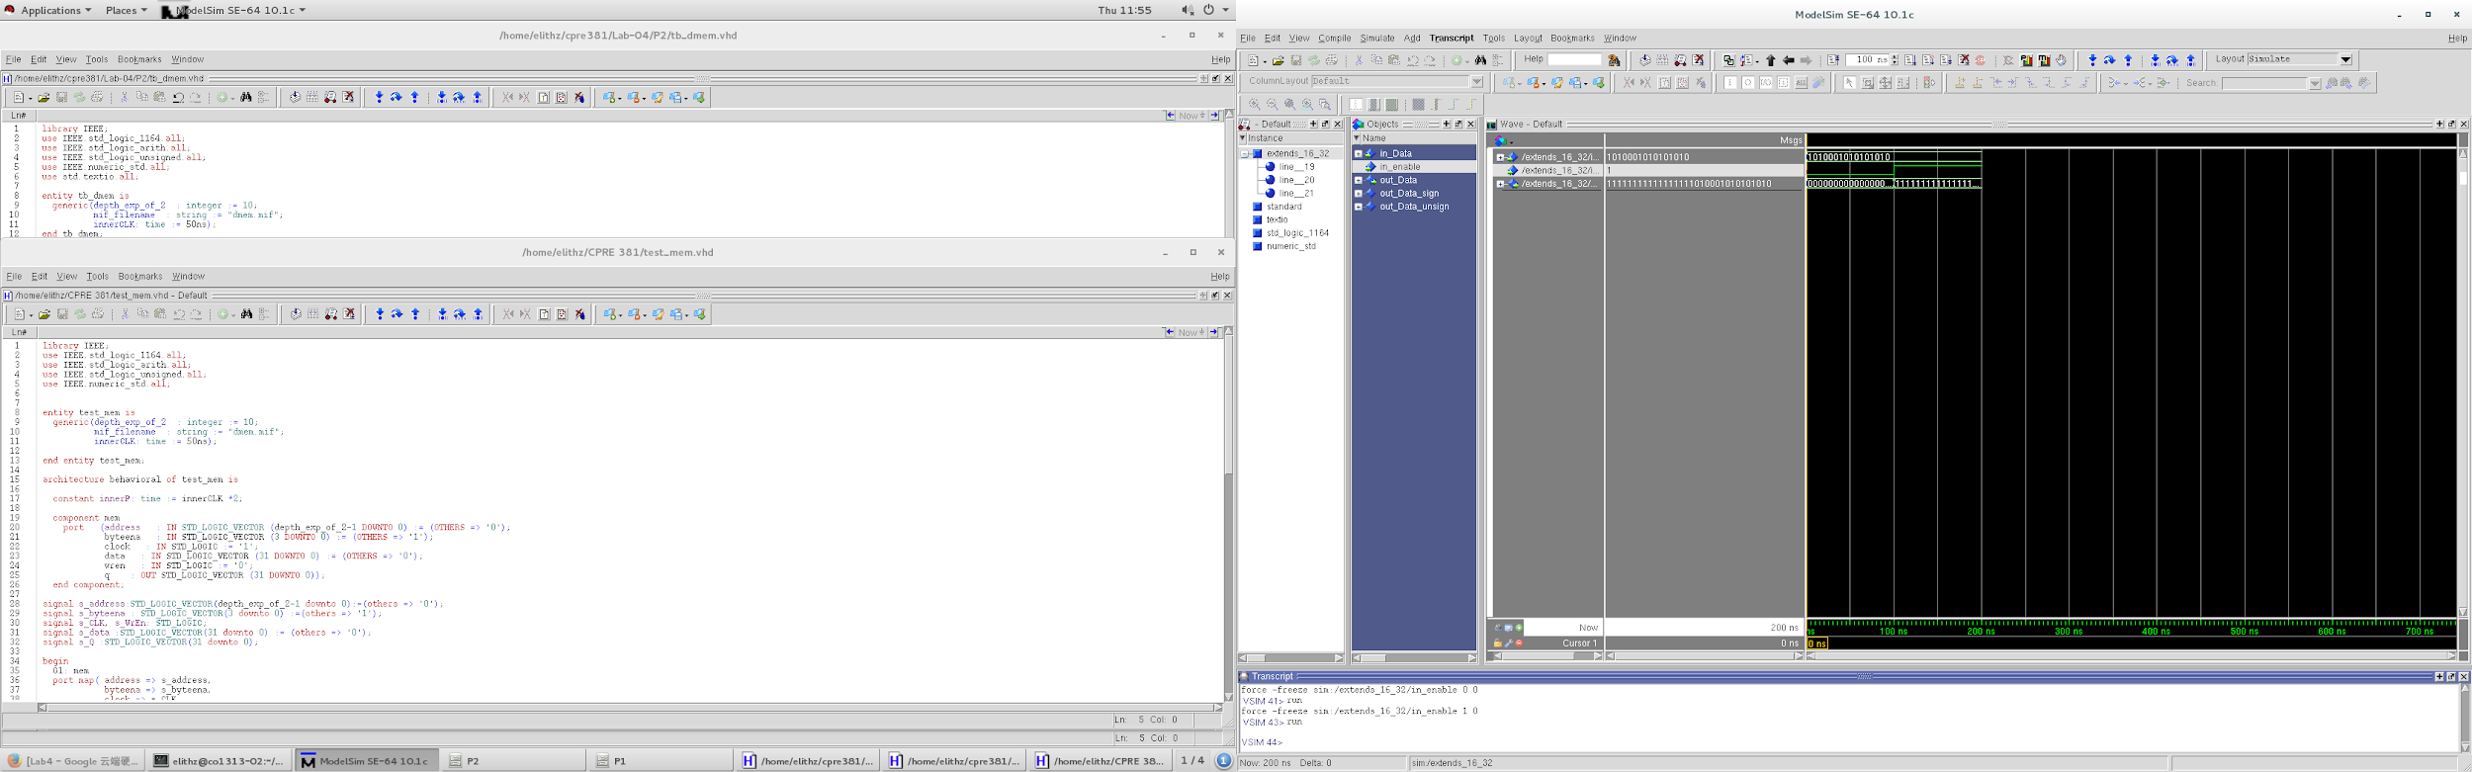

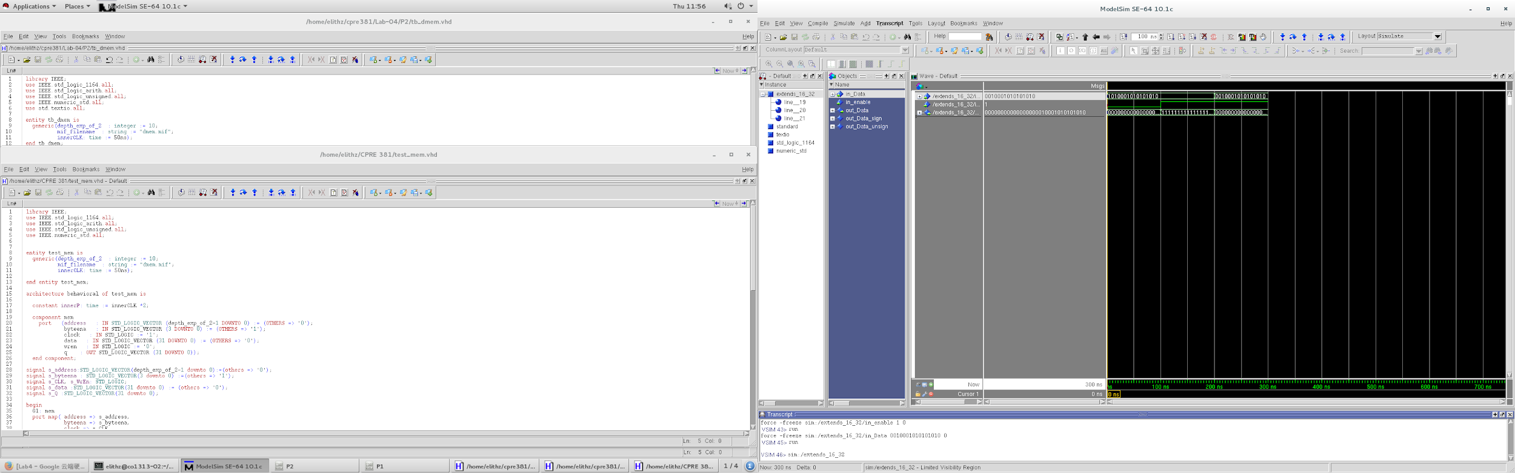

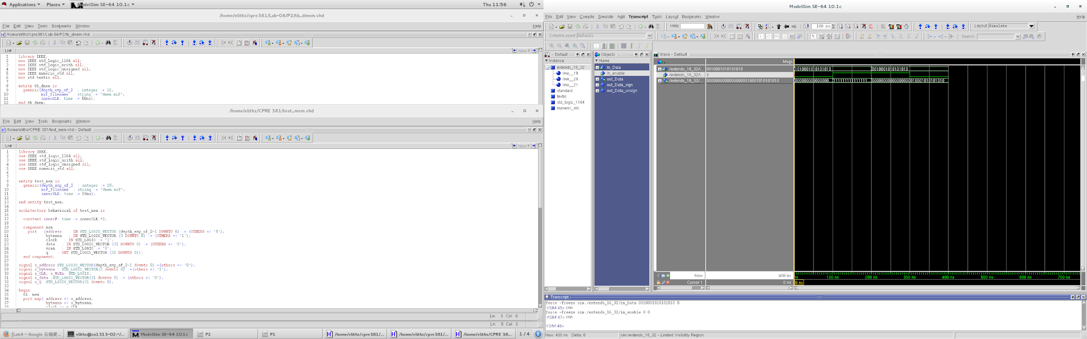

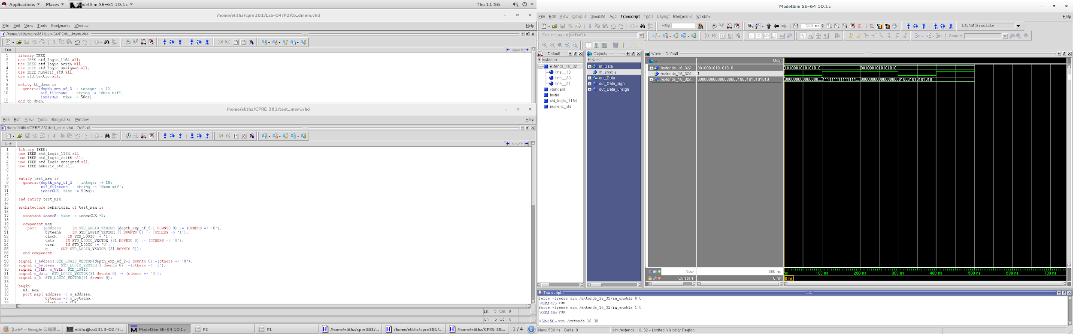

Part 2.

b).

there are 5 input port and 1 output port in the port map. the address port is the address that used to access the memory address, and byteena is byte enable which is used to control which byte to change; and clock is the system clock port, data is the data that will be stored into destination address; and the wren is the write enable which will be used to enable the write action. and q is the data that read from memory.

c).

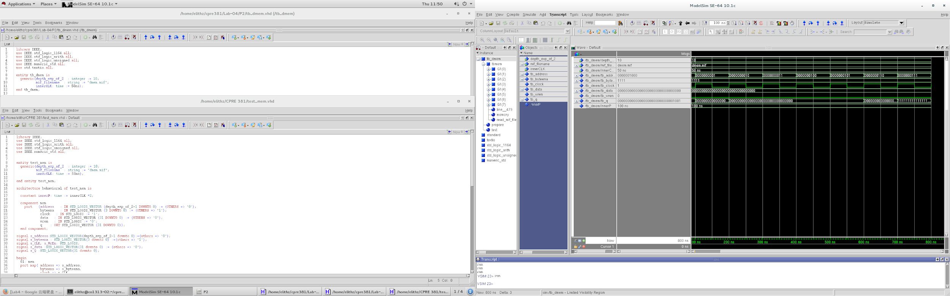

d). this wave form is discribing the actions that I mentioned in prelab.

Part 3.

We did not finish this part because of no enough time.